Thực hành Kiến trúc máy tính tuần 5

Họ và tên: Nguyễn Khắc Hiếu

MSSV: 20225839

Assignment 1

#Laboratory Exercise 5, Assignment 1

.data

test: .asciiz "Nguyen Khac Hieu 20225839"

.text

li $v0, 4 # $v0 = 4

la $a0, test # Dia chi cua xau test duoc load vao $a0

syscall # Loi goi dich vu he thong

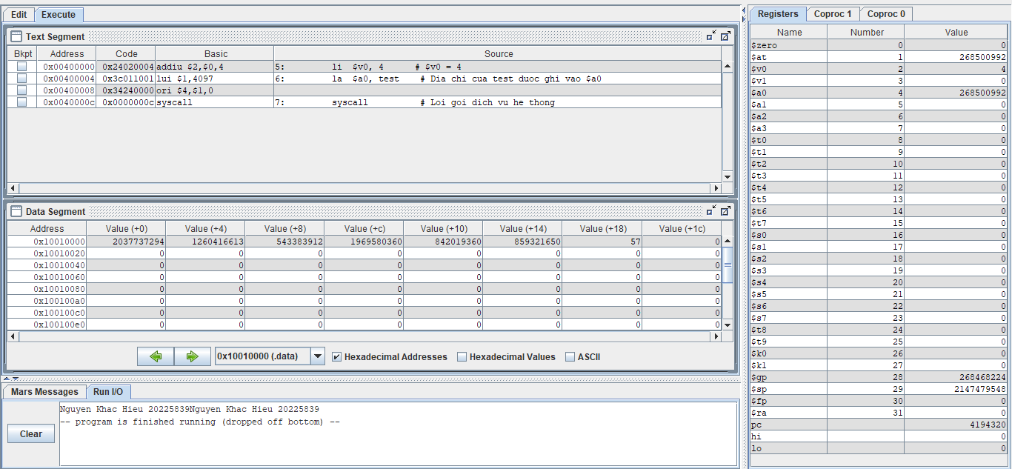

=> Kết quả trên đúng với lý thuyết

Assignment 2

#Laboratory Exercise 5, Assignment 2

.data

str1: .asciiz "The sum of "

str2: .asciiz " and "

str3: .asciiz " is "

.text

li $s0, 4 # $s0 = 6

li $s1, 8 # $s1 = 13

add $s2, $s0, $s1 # $s2 = $s0 + $s1 = 6 + 13

# Print string "str1"

li $v0, 4

la $a0, str1

syscall

# Print $s0

li $v0, 1

move $a0, $s0

syscall

# Print string "str2"

li $v0, 4

la $a0, str2

syscall

# Print $s1

li $v0, 1

move $a0, $s1

syscall

# Print string "str3"

li $v0, 4

la $a0, str3

syscall

# Print $t0

li $v0, 1

move $a0, $s2

syscall

Exit:

li $v0, 10

syscall

* Bắt đầu thực hiện chương trình

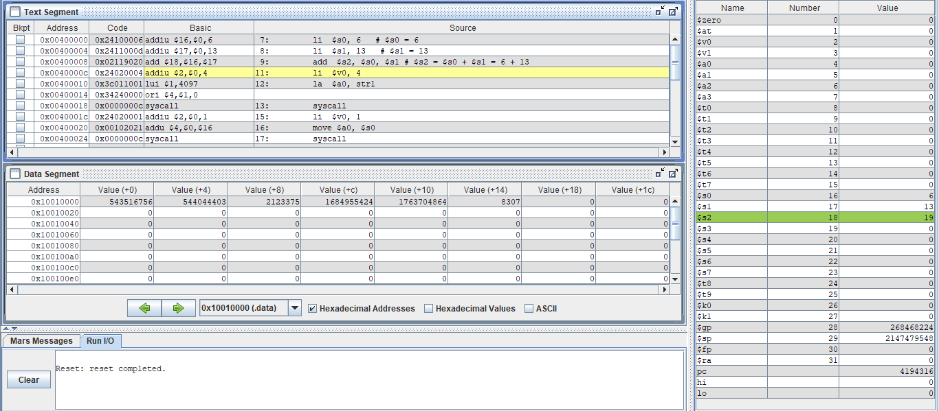

* In “The sum of”

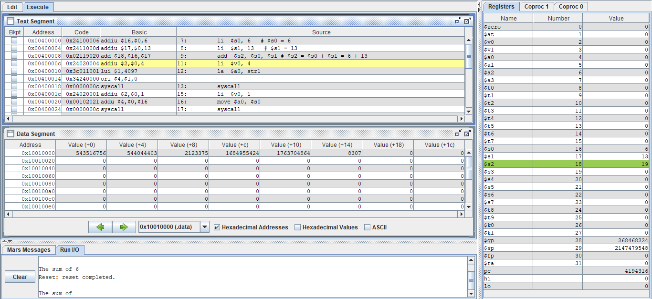

* In $s0



* In “and”

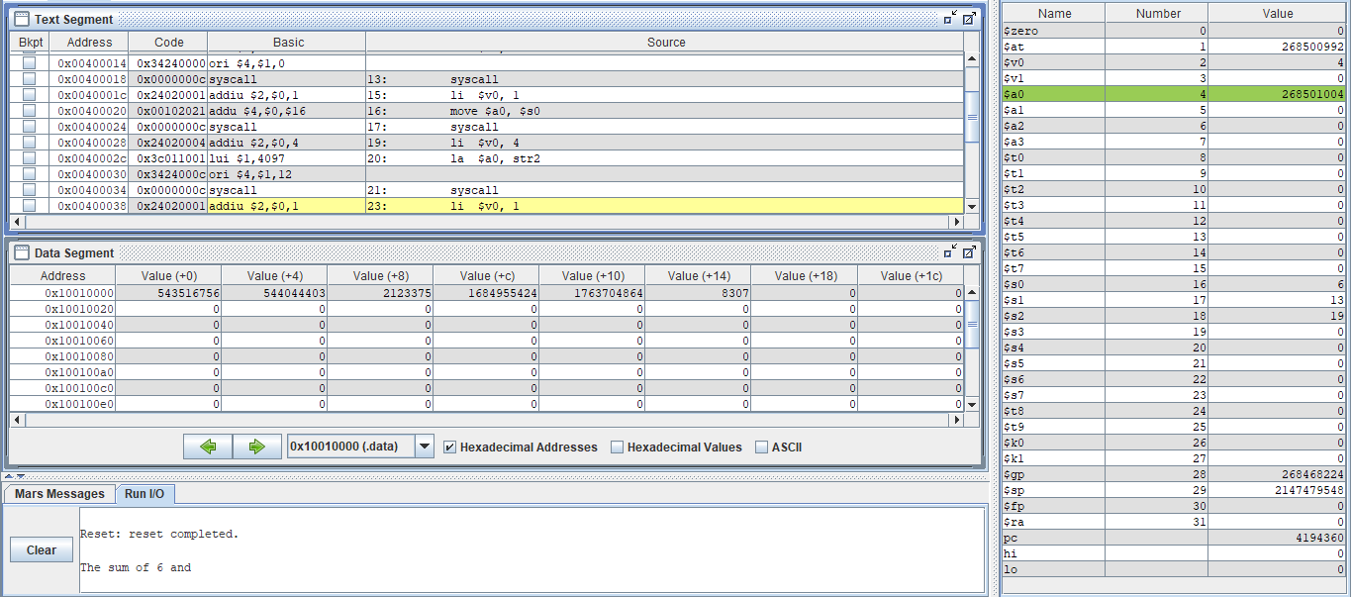

* In $s1

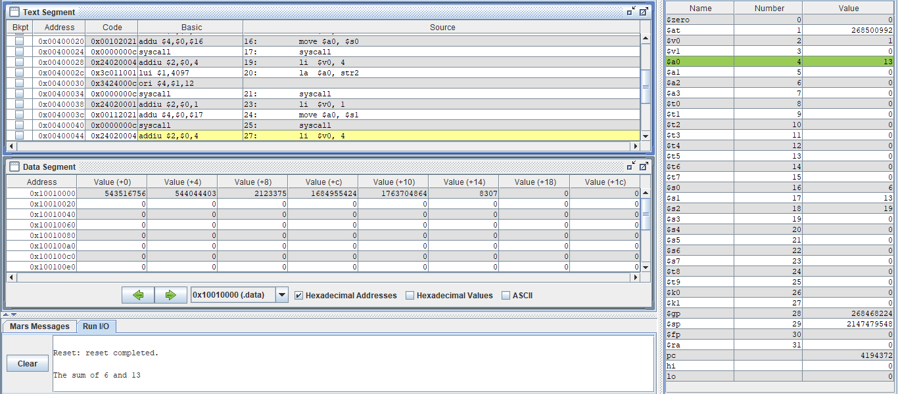

* In “is”

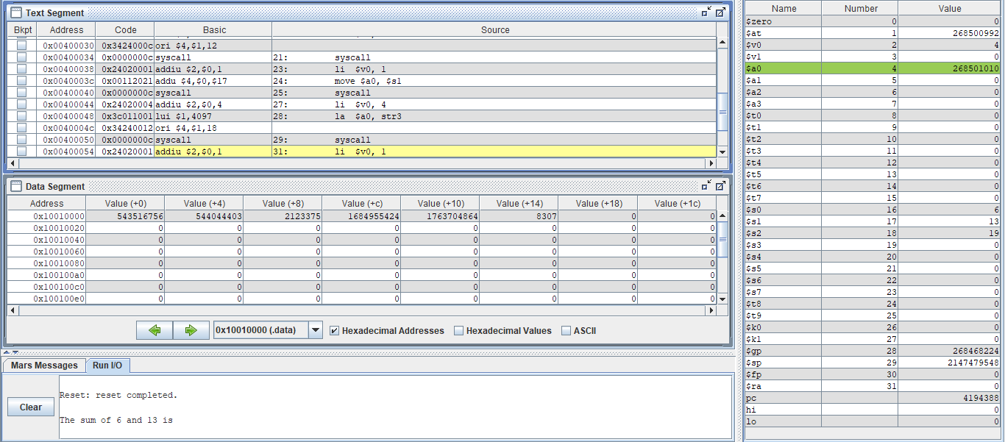

* In $s2

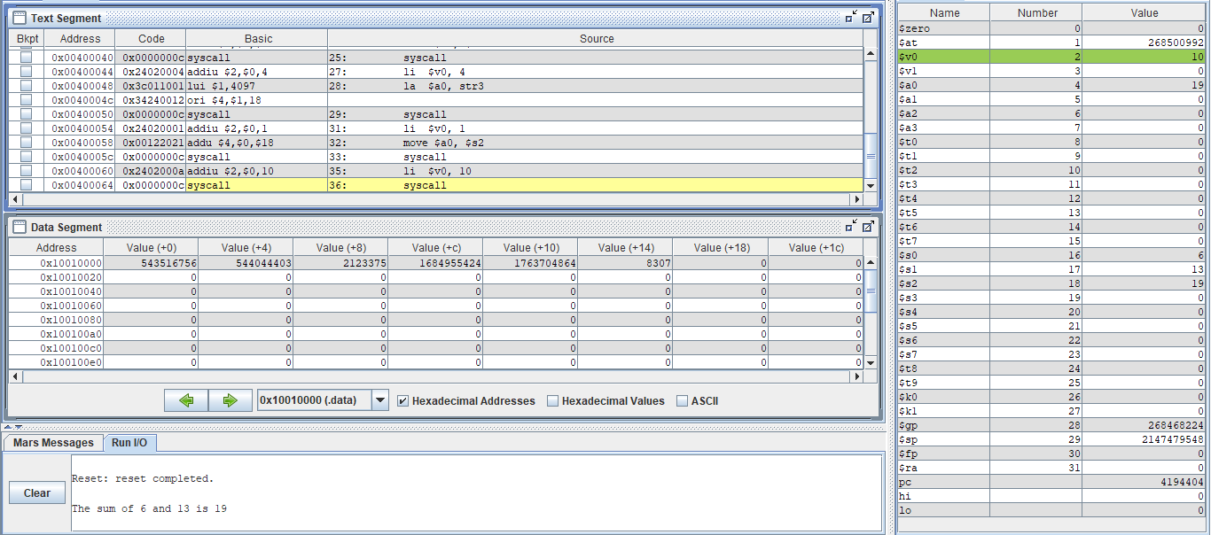

* Kết thúc chương trình

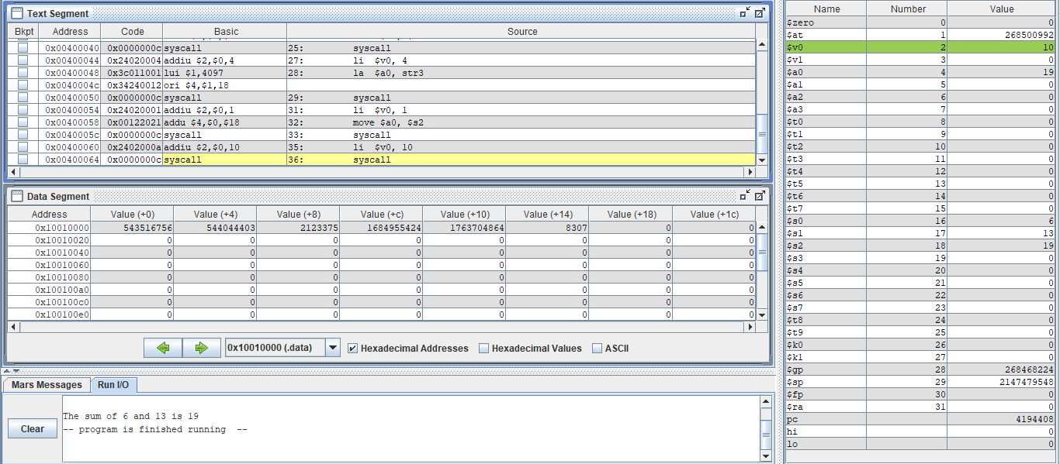

Assignment 3

#Laboratory Exercise 5, Assignment 3

.data

x: .space 32 # destination string x, empty

y: .asciiz "Hieu" # source string y

.text

strcpy:

add $s0,$zero,$zero # $s0 = i = 0

la $a0, x # load dia chi cua x vao $a0

la $a1, y # load dia chi cua y vao $a1

L1:

add $t1,$s0,$a1 # $t1 = $s0 + $a1 = i + y[0]

# = address of y[i]

lb $t2,0($t1) # $t2 = value at $t1 = y[i]

add $t3,$s0,$a0 # $t3 = $s0 + $a0 = i + x[0]

# = address of x[i]

sb $t2,0($t3) # x[i]= $t2 = y[i]

beq $t2,$zero,end_of_strcpy # if y[i] == 0, exit

nop

addi $s0,$s0,1 # $s0 = $s0 + 1 <-> i = i + 1

j L1 # next character

nop

end_of_strcpy:

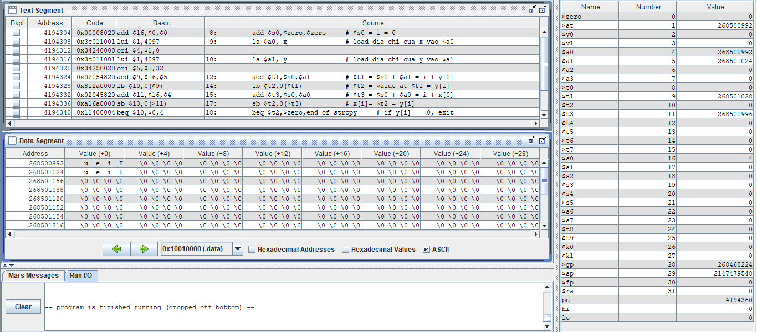

=> Kết quả trên đúng với lý thuyết

Assignment 4

#Laboratory Exercise 5, Assignment 4

.data

string: .space 50

Message1: .asciiz "Nhap xau: "

Message2: .asciiz "Do dai xau la: "

.text

main:

get_string:

li $v0, 54 # Get a string from dialog

la $a0, Message1 # Load address of the Message1 to $a0

la $a1, string # Load address of input buffer "string" to $a1

la $a2, 50 # Maximum number of characters to read = 50

syscall

get_length:

la $a0,string # $a0 = address(string[0])

add $t0,$zero,$zero # $t0 = i = 0

check_char:

add $t1,$a0,$t0 # $t1 = $a0 + $t0

# = address(string[i])

lb $t2, 0($t1) # $t2 = string[i]

beq $t2, $zero, end_of_str # is null char?

addi $t0, $t0, 1 # $t0 = $t0 + 1 -> i = i + 1

j check_char

end_of_str:

end_of_get_length:

print_length:

addi $t0, $t0, -1 # -1 de tru di dau enter

li $v0, 56

la $a0, Message2

move $a1, $t0

syscall

* Nhập xâu “khachieu”

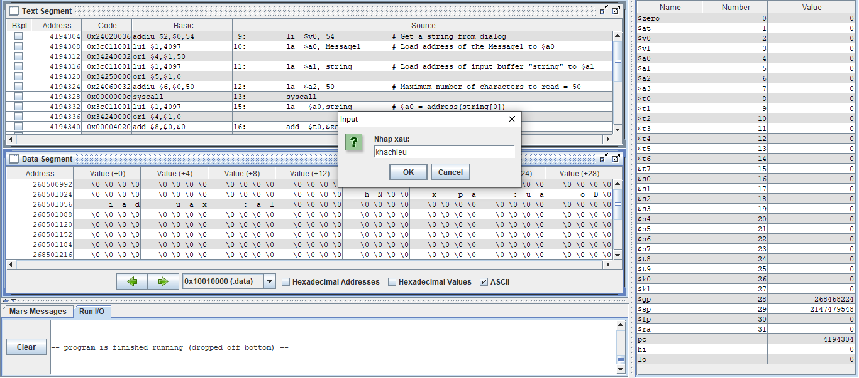

* Xâu có 8 ký tự => Kết quả trên đúng với lý thuyết

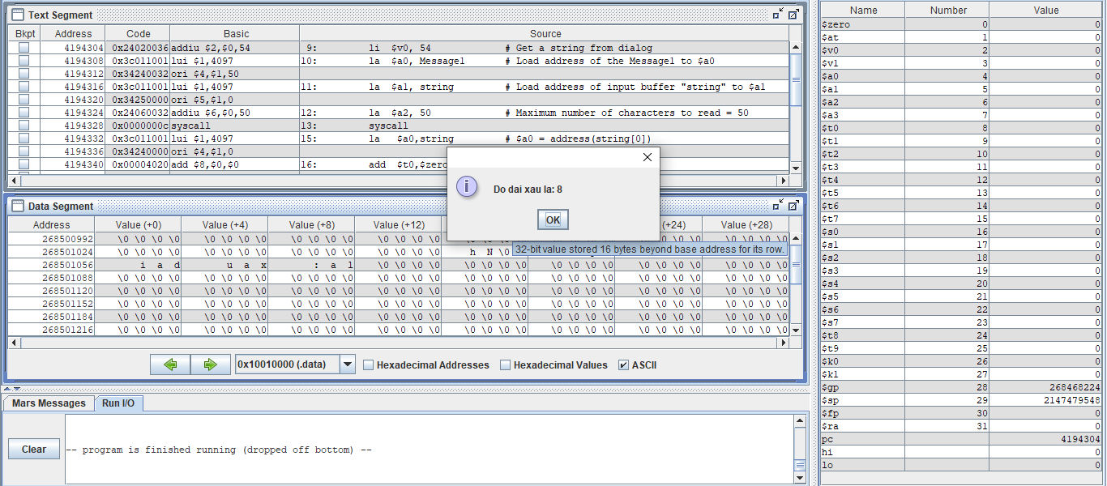

Assignment 5

#Laboratory Exercise 5, Assignment 5

.data

get_char: .space 20

message1: .asciiz "Nhap ky tu thu "

message2: .asciiz ": "

message3: .asciiz "\n"

message4: .asciiz "Chuoi vua nhap (dao nguoc lai): "

.text

li $s0, 20 # N = 20

li $s1, 0 # i = 0

la $s2, get_char # Load address of get_char[0]

li $s3, 10 # Char \n in ASCII

read_char:

beq $s1, $s0, end_read_char # i = N branch to exit

# Print "Nhap ky tu thu i: "

li $v0, 4

la $a0, message1

syscall

addi $t1, $s1, 1

li $v0, 1

move $a0, $t1

syscall

li $v0, 4

la $a0, message2

syscall

li $v0, 12 # Read character

syscall

move $t0, $v0

beq $t0, $s3, end_read_char # Press "Enter" branch to exit

li $v0, 4

la $a0, message3

syscall

add $s5, $s2, $s1 #$s5 = Address of get_char[i] = get_char[0] + i

sb $t0, 0($s5) #Store character to get_char[i]

addi $s1, $s1, 1 # i++

j read_char

end_read_char:

li $v0, 4

la $a0, message4

syscall

print_string:

li $v0, 11

lb $a0, 0($s5)

syscall

beq $s5, $s2, exit

addi $s5, $s5, -1

j print_string

exit:

li $v0, 10

syscall

* Nhập xâu “abcdefghijk”:

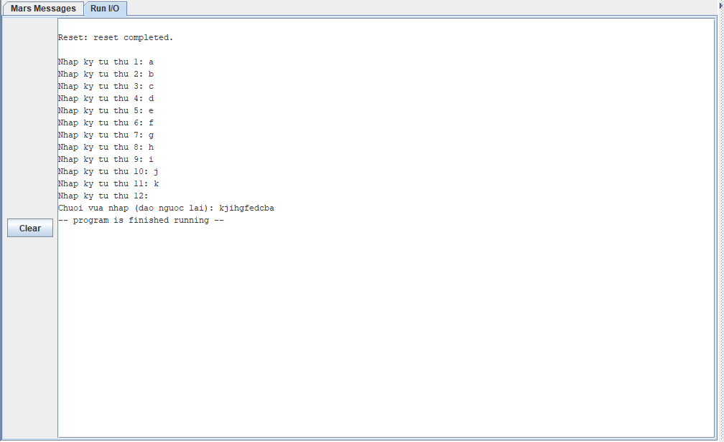

* Nhập đủ 20 ký tự:

